Executive Incident Memorandum

Confidential – Internal Incident Communication
To | Chief Executive Officer
From | IT Operations Manager
Date | June 2, 2026
Subject | Critical programming error in the client scheduling update
Scenario | Scenario 2: Critical Error

Executive Summary
A critical programming error has been identified in the client scheduling update that is contractually due in seven days. In its current state, the flawed build would let end users schedule unlimited services instead of the contracted one service per purchase. The defect was traced to a single unreviewed developer commit and a quality assurance (QA) sign-off that was bypassed across 12 code modules, and it was discovered four days after the build reached staging (Western Governors University [WGU], n.d.).
Recommended action: authorize a short, controlled delay to roll back, remediate, and fully retest the build rather than ship the known defect. A delay carries a $150,000 weekly service-level agreement (SLA) penalty, but releasing the flawed update would expose the client to roughly $2.4 million in lost revenue in the first 30 days, an estimated 3,500 complaints in the first week, and reputational harm to our company that could cost one to two contracts valued at about $500,000 each (WGU, n.d.). The cost of releasing the defect is materially greater than the cost of fixing it first.

Business Impact
Impact area | Current assessment | Why it matters to leadership
Client operations | 200,000 end users depend on the scheduling system. | A defective release would disrupt a large, customer-facing service workflow.
Client financial exposure | Unlimited free services ≈ $2.4M in lost client revenue in the first 30 days. | The cost of shipping the defect far exceeds the cost of a controlled delay.
Contract / SLA exposure | Delay penalty of $150,000 per week late. | Material but manageable next to a defective release.
Internal cost | $85,000 rework and QA retesting; 2,100 staff hours diverted. | Leadership support is needed to protect capacity and prioritize the fix.
Reputation risk | Potential loss of 1–2 contracts at ≈ $500,000 each. | Transparent handling preserves client trust and our reliability brand.

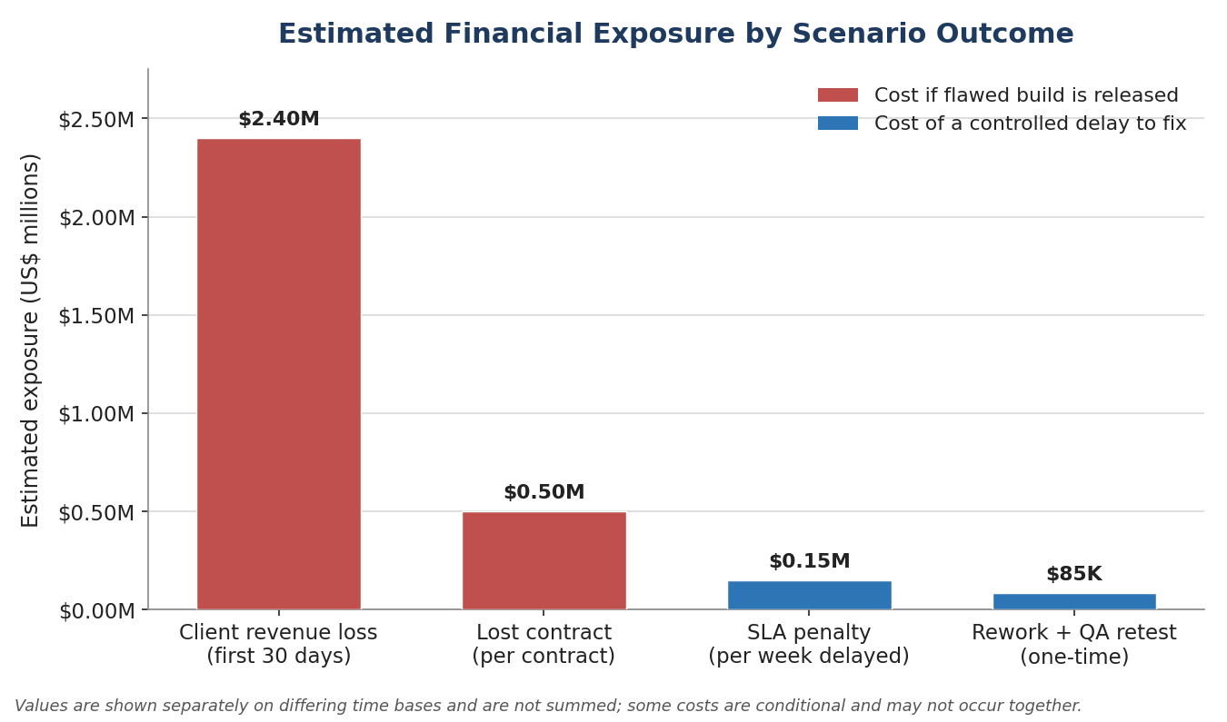
Figure 1. Estimated financial exposure by scenario outcome. Values are presented separately on differing time bases and are not summed, because some costs are conditional and may not occur together.

Corrective Timeline and Milestones
Milestone | Target date | Owner | Expected output
Executive review | June 2, 2026 | IT Operations Manager | Approval to delay the flawed release and begin containment.
Roll back staging build | June 4, 2026 | IT Ops + Release Eng. | Flawed build removed from the promotion path.
Code remediation complete | June 8, 2026 | Development Lead | Corrected scheduling logic with completed peer review.
Full QA retest + sign-off | June 14, 2026 | QA Lead | 100% QA compliance across all affected modules.
Release readiness review | June 14, 2026 | PM + Legal + Client Services | Go / no-go decision and approved client release notes.
Client delivery window | June 14–16, 2026 | Account Manager + Client Services | Corrective release delivered ≈ 5–7 days after the contract deadline.

Client Communication Strategy
Designate the account manager as the single client communication owner, supported by IT, Legal, and Client Services, so the client receives one consistent message.
- Frame the delay as a controlled quality action: we caught a risk in staging and are preventing customer-facing financial harm before production.
- Provide a concise remediation timeline, the expected delivery window, and a commitment to daily status updates until release readiness is confirmed.
- Focus client messaging on quality controls, containment, and safeguards rather than individual blame.

Mitigation and Prevention Strategy
- Containment: freeze promotion of the flawed build and complete rollback within two days.
- Remediation: correct the scheduling logic, require peer review, and complete full QA retesting of every affected module.
- Governance: enforce a 100% QA-compliance mandate with zero release-bound bypasses.
- Prevention: adopt automated code review for 90% of new commits by Q3 and fund an estimated $250,000 annual program for tooling and training — less than the value of a single lost contract.

Decision Requested
Approve a controlled delay of the client update and authorize the response team to prioritize remediation, QA retesting, and client communication. This path accepts a short, bounded delivery delay in exchange for materially lower financial, operational, and reputational risk than releasing a known defect.

References
Western Governors University. (n.d.). E011.1 Technical communication: Scenario 2 – Critical error [Course scenario].

